Chapter 1 This is Our Home

TRUE/FALSE

1. The oldest land formation in North America is the Appalachian Mountains.
A. True
B. False

ANS: T PTS: 1 DIF: Knowledge REF: Chapter 1 Section 2
TOP: Physical Features

2. The loggerhead turtle is the state reptile of South Carolina.
A. True
B. False

ANS: T PTS: 1 DIF: Knowledge REF: Chapter 1 Section 2
TOP: State Symbols

3. The terrain and soil of the Blue Ridge region is well suited for farming.
A. True
B. False

ANS: F PTS: 1 DIF: Application REF: Chapter 1 Section 2
TOP: Regions

4. The Blue Ridge region is the coldest and wettest in the state because of its elevation.
A. True
B. False

ANS: T PTS: 1 DIF: Application REF: Chapter 1 Section 2
TOP: Regions

5. The Piedmont Region makes up approximately one-half of the state of South Carolina.
A. True
B. False

ANS: F
The Piedmont Region makes up approximately one-third of the state of South Carolina.

PTS: 1 DIF: Knowledge REF: Chapter 1 Section 2
TOP: Regions

6. The state stone in South Carolina is the blue granite from Fairfield County.
A. True
B. False

ANS: T PTS: 1 DIF: Knowledge REF: Chapter 1 Section 2
TOP: State Symbols

7. Greenville is considered the geographic center of the state.
A. True
B. False

ANS: F
Columbia is approximately the geographic center of the state.

PTS: 1 DIF: Knowledge REF: Chapter 1 Section 2
TOP: Physical Features

8. The largest river delta on the Atlantic coast is Santee Delta.
A. True
B. False

ANS: T PTS: 1 DIF: Knowledge REF: Chapter 1 Section 2
TOP: Waterways

9. The soils of the sandhills are generally not very productive.
A. True
B. False

ANS: T PTS: 1 DIF: Application REF: Chapter 1 Section 2
TOP: Physical Features

10. The largest landform region in South Carolina is the Coastal Plain Region.
A. True
B. False

ANS: T PTS: 1 DIF: Knowledge REF: Chapter 1 Section 2
TOP: Regions

11. Huge pine forests are found in the Coastal Plain Region.
A. True
B. False

ANS: T PTS: 1 DIF: Knowledge REF: Chapter 1 Section 2
TOP: Regions

12. In 1886 the Charleston earthquake killed 83 people and destroyed one-quarter of the buildings.
A. True
B. False

ANS: T PTS: 1 DIF: Knowledge REF: Chapter 1 Section 2
TOP: Climate

13. The fastest growing part of the state in terms of population and tourism is the Coastal Zone Region.
A. True
B. False

ANS: T PTS: 1 DIF: Analysis REF: Chapter 1 Section 2
TOP: Regions

MULTIPLE CHOICE

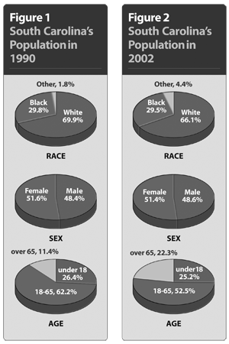

1. According to the two graphs, by what percent have races other than black and white grown from 1990 to 2002?
A. | 1.2 percent
B. | 1.6 percent
C. | 2.3 percent
D. | 2.6 percent

ANS: D PTS: 1 DIF: Application REF: Chapter 1 Section 1
TOP: Population

2. According to the two graphs, what category of data has stayed relatively the same from 1990 to 2002?
A. | age
B. | race
C. | sex
D. | other

ANS: C PTS: 1 DIF: Application REF: Chapter 1 Section 1
TOP: Population

3. According to the two graphs, what area has seen the largest increase between 1990 and 2002?
A. | age: under 18
B. | age: over 65
C. | race: blacks
D. | sex: women

ANS: B PTS: 1 DIF: Application REF: Chapter 1 Section 1
TOP: Population

4. According to the two graphs, what area has had the largest decline from 1990 to 2002?
A. | age: 18-65
B. | age: under 18
C. | race: blacks
D. | sex: male

ANS: A PTS: 1 DIF: Application REF: Chapter 1 Section 1
TOP: Population

5. From the information on the graphs, which statement BEST describes the change in South Carolina’s population between 1990 and 2002?
A. | The population is declining.
B. | The population is getting older.
C. | The population is getting younger.
D. | The population is becoming less diverse.

ANS: B PTS: 1 DIF: Analysis REF: Chapter 1 Section 1
TOP: Population

6. What is the most active month for hurricanes?
A. | June
B. | July
C. | August
D. | September

ANS: D PTS: 1 DIF: Application REF: Chapter 1 Section 3
TOP: Climate

7. What type of climate does South Carolina have?
A. | continental
B. | humid continental
C. | tropical
D. | subtropical

ANS: D PTS: 1 DIF: Knowledge REF: Chapter 1 Section 3
TOP: Climate

8. What is the most extensive system of rivers and lakes in South Carolina?
A. | Catawba System
B. | Pee Dee System
C. | Santee System
D. | Savannah System

ANS: C PTS: 1 DIF: Application REF: Chapter 1 Section 3
TOP: Waterways

9. Which river is a tributary of the Savannah River?
A. | Congaree
B. | Saluda
C. | Tugaloo
D. | Tyger

ANS: C PTS: 1 DIF: Knowledge REF: Chapter 1 Section 3
TOP: Waterways

COMPLETION

1. _________________includes landforms, soils, bodies of water, descriptions of places, and climate.

ANS: : Geography

PTS: 1 DIF: Comprehension REF: Chapter 1 Section 1
TOP: Vocabulary

2. __________________is the precise position by longitude and latitude.

ANS: Absolute location

PTS: 1 DIF: Knowledge REF: Chapter 1 Section 1
TOP: Vocabulary

3. The highest peak in the South Carolina Range of the Blue Ridge Range is ____________________Mountain.

ANS: Sassafras Mountain

PTS: 1 DIF: Knowledge REF: Chapter 1 Section 2
TOP: Physical Features

4. Animal life is called ____________________

ANS: : fauna

PTS: 1 DIF: Knowledge REF: Chapter 1 Section 2
TOP: Vocabulary

5. Rain, snow, sleet and hail are called _______________________.

ANS: : precipitation

PTS: 1 DIF: Comprehension REF: Chapter 1 Section 2
TOP: Vocabulary

6. Granite outcroppings are called ______________________.

ANS: : monadnocks

PTS: 1 DIF: Knowledge REF: Chapter 1 Section 2
TOP: Vocabulary

7. ____________________is approximately the geographic center of the state.

ANS: : Columbia

PTS: 1 DIF: Knowledge REF: Chapter 1 Section 2
TOP: Regions

8. The ___________________________ of South Carolina is the longest black river in the world.

ANS: Edisto River

PTS: 1 DIF: Knowledge REF: Chapter 1 Section 3
TOP: Waterways

MATCHING

Match the term with its definition.
A. | climate | I. | latitude
B. | elevation | J. | longitude
C. | environment | K. | monadnock
D. | fauna | L. | precipitation
E. | flora | M. | tornado
F. | geography | N. | tributary
G. | hurricane | O. | weather
H. | kudzu

1. granite outcroppings

2. earth’s description

3. height above sea level

4. animal life

5. distance, north and south of the equator, measured in degrees

6. natural vegetation

7. grass used to control erosion

8. windstorm characterized by a funnel-shaped cloud

9. distance east or west of the prime meridian measured in degrees

10. large low-pressure air masses that generate high winds

11. surroundings

12. creeks that feed into larger rivers

13. rain, snow, sleet, hail

14. long-term view of atmospheric conditions

15. short-term atmospheric conditions

1. ANS: K PTS: 1 DIF: Knowledge REF: Chapter 1 Section 2
TOP: Vocabulary

2. ANS: F PTS: 1 DIF: Knowledge REF: Chapter 1 Section 1
TOP: Vocabulary

3. ANS: B PTS: 1 DIF: Knowledge REF: Chapter 1 Section 2
TOP: Vocabulary

4. ANS: D PTS: 1 DIF: Knowledge REF: Chapter 1 Section 2
TOP: Vocabulary

5. ANS: I PTS: 1 DIF: Knowledge REF: Chapter 1 Section 1
TOP: Vocabulary

6. ANS: E PTS: 1 DIF: Knowledge REF: Chapter 1 Section 2
TOP: Vocabulary

7. ANS: H PTS: 1 DIF: Knowledge REF: Chapter 1 Section 2
TOP: Vocabulary

8. ANS: M PTS: 1 DIF: Knowledge REF: Chapter 1 Section 3
TOP: Vocabulary

9. ANS: J PTS: 1 DIF: Knowledge REF: Chapter 1 Section 1
TOP: Vocabulary

10. ANS: G PTS: 1 DIF: Knowledge REF: Chapter 1 Section 3
TOP: Vocabulary

11. ANS: C PTS: 1 DIF: Knowledge REF: Chapter 1 Section 1
TOP: Vocabulary

12. ANS: N PTS: 1 DIF: Knowledge REF: Chapter 1 Section 2
TOP: Vocabulary

13. ANS: L PTS: 1 DIF: Knowledge REF: Chapter 1 Section 2
TOP: Vocabulary

14. ANS: A PTS: 1 DIF: Knowledge REF: Chapter 1 Section 3
TOP: Vocabulary

15. ANS: O PTS: 1 DIF: Knowledge REF: Chapter 1 Section 3
TOP: Vocabulary

ESSAY

1. Explain reasons why people live in South Carolina.

ANS:
Answers will vary, but may include
-abundant natural resources
-excellent educational opportunities
-four seasons
-wide variety of sports and recreational opportunities

PTS: 1 DIF: Comprehension REF: Chapter 1 Section 3
TOP: Modern South Carolina

2. 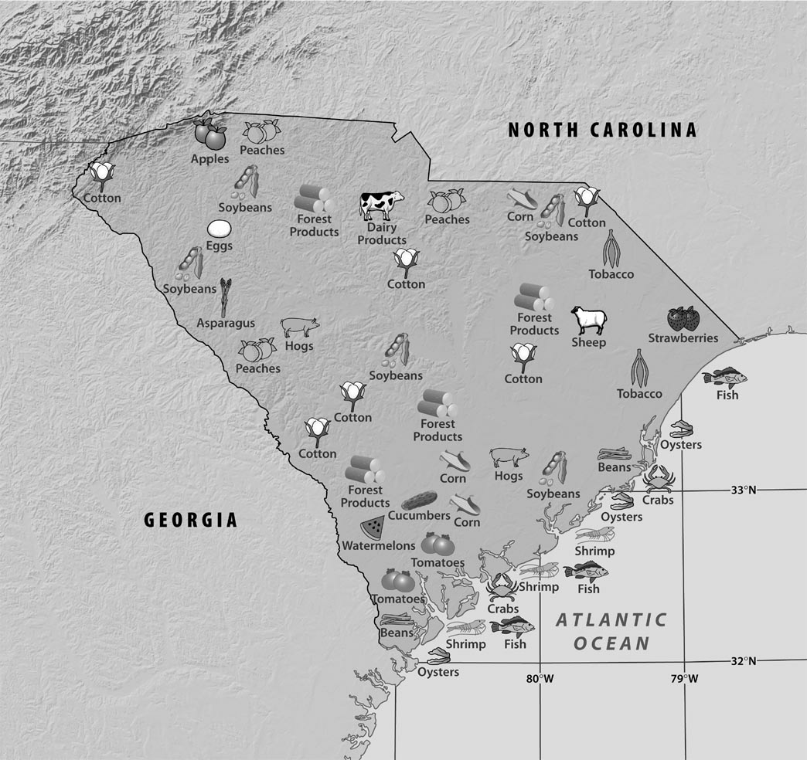

Look at the map and make a list of the various farm products found in South Carolina. Then make a chart and categorize the products as Vegetable, Fruit, Animal, and Other. Finally, write a summary statement based on the data in the chart to explain farming in South Carolina.

ANS:
Vegetable | Fruit | Animal | Other
soybeans  asparagus  cucumbers  corn  beans | apples  peaches  strawberries  watermelons  tomatoes | dairy cows  sheep  hogs | cotton  tobacco

Answers will vary but might say: South Carolina produces more fruits and vegetables than animal products.

PTS: 1 DIF: Comprehension REF: Chapter 1 Section 1
TOP: The Economy

